World G18 Somalia

Environmental problems and toxic waste dumping in Somalia
(No 4 in a series of essays addressing current issues in Somalia)

Toxic waste is waste material that can cause death or injury to living creatures. It spreads easily and can contaminate lakes and rivers. The term is often used interchangeably with “hazardous waste”, or discarded material that can pose a long-term risk to health or environment.
Toxic wastes often contains carcinogens and exposure to these by some route, such as leakage or evaporation from the storage, causes cancer to appear at increased frequency in exposed individuals. For example, a cluster of the rare blood cancer Polycythemia Vera was found around a toxic waste dump site in northeast and South Central Somalia coasts.
People encounter these toxins buried in the ground, in stream runoff, in groundwater that supplies drinking water or in floodwaters as happened after Hurricane Katrina. Some toxins such as mercury persist in the environment and accumulate. Humans or animals often absorb them when they eat fish.
Toxic wastes containing organic carcinogens can be destroyed by incineration at high temperatures, which is expensive. However, if the waste contains heavy metals or radioactive isotopes, this is difficult.

AGRICULTURE IN SOMALIA
Agriculture was once a way of life for most people in Somalia. The vast majority of cultivated land is used by small farmers for subsistence agriculture. Earlier research has shown that returns in agricultural investment can be high but during the last two decades of civil War in Somalia. many farmers have failed to make profitable investments due to the lack of microfinance and educational support.

Land Suitability Needs for Irrigated Agriculture
Somalia has a long history of irrigated agriculture on the alluvial plains of the Juba and Shabelle Rivers. In Somalia, the cultivatable area mainly between these two rivers in the south was estimated to 8 million ha in 1985, 13% of the total area, while 980,000 ha were cultivated by annual crops but only about 18,000 ha consisted of permanent crops. Main crops are maize, sorghum, sugarcane and rice while bananas are the principal cash crop accounting for 40% of export earnings in 1988. In 1985, total water withdrawal was estimated at 870 million m3, 97% of which was drawn to irrigate agriculture. Equivalent to 8% of the country's total annual available water resources, this indicates country's technical water scarcity due to the low level of infrastructure development.
In 1980 about 50,000 ha were under controlled irrigation and110,000 ha under flood irrigation (Alim,1987). Large commercial schemes for irrigated sugarcane, rice, banana, maize,sSorghum, citrus and other fruits used to operate in the Shabelle below Jowhar and in the Juba near Jilib. Since the early 1990s much of the irrigation infrastructure has deteriorated due to the civil war and lack of care for the environment. Opportunities exist to revive old schemes or to grow the same crops in smaller schemes.

Three LUTs were defined and selected for the suitability assessment:

Ir: Rice. Flood irrigation of paddy rice, small-scale, low-medium input of irrigation management and infrastructure);
IC: Citrus. (and other fruits). Controlled irrigation, medium-high input (seedlings, pesticides, irrigation management and infrastructure);
Is: Sugarcane. Controlled irrigation, medium-high input (pesticides, irrigation management and infrastructure). The land suitability evaluation that was carried out concentrated on the suitability of the land (notable soils and topography) in favour of the availability and quality of water for irrigation. Also, the assumption was made that water is available in low-lying areas on the banks of the Juba and Shebelle rivers suitable for banana, maize and sorghum, sesame, lemon, mango, papaya and other fruits.

Physical degradation
Physical degradation mainly refers to soil loss through erosion but also includes phenomena such as the deposition of undesirable sediments, deteriorating soil structure and increased stoniness. Potential annual soil loss through accelerated soil erosion by water was calculated by using the Revised Universal Soil Loss Equation (RUSLE). The result shown is Potential annual soil loss ranges from very low (0 – 1.0 ton ha-1 yr-1) on the almost flat plains in the north and west of the study area to very high (> 200 ton ha-1 yr-1) locally on the steep slopes of the south-east and north-west. Most of the study area (41%) has a low potential annual soil loss of 1-10 tons ha-1 yr-1.The average potential annual soil loss for the whole study area is estimated at slightly over 20 ton ha-1. In addition to topography (slope), soil cover is an important factor that influences potential soil loss. Overstocking, poor cropping practices and felling trees for firewood, charcoal or fodder lead to decreased soil cover and increased soil loss. The presence of urban centres such as in the South and Borama in the north also contribute to the loss of vegetative cover as a result of fuel-wood collection and urban sprawl.

Major threats facing the environment in Somalia include:
1. Burning of forests and the uprooting of mature trees for charcoal to be exported for hard currency,
2. Due to poor maintenance and fuel shortages for major water rig points that are now almost idle, nomads overpopulate areas with water wells & bore holes etc leading to severe land degradation in those areas.
3. Lack of properly graded roads leads to truckers and private cars choosing to drive on virgin land leading to hundreds of kilometres of dead, dust and useless land. Also this contributes to the creation of dry rivers and canyons that spoil pasture land.
4. Wildlife is poached without any mercy with most emigrating to neighbouring countries.
5. Lack of renewable energy sources results in heavy dependency on wood/charcoal for cooking.
6. Heavy felling of trees by nomads for sheltering livestock. As 70% of Somalis are nomads following the rains, their constant movement increases the need for more shelters for both humans and livestock which in turn leads to more trees being felled.
7. Foreign industrial scale fishing fleets using seabed trawling nets.
8. The recently introduced habit of dumping nuclear and toxic waste on or close to Somalia’s shores has been too slowly addressed.
9. Physical degradation that mainly refers to soil loss and erosion includes phenomena such as the deposition of undesirable sediments, deteriorating soil structure and increased stoniness.
Pastoral livestock resources in Somalia

Livestock or pastoral production is an important economic activity in Somalia. Like other pastoral systems, livestock production at farm level contributes as much as 70% to economic production or income (RCMRD et al, 2006).
The absence of livestock care has led the Somali economy into a vicious circle. The decimation of herds pushed the nomadic pastoralists into starvation which in turn affected grain producers who had depended on them for the sale and barter of cattle grain. The entire social fabric of the pastoralist economy was undone leading to the collapse in foreign exchange earnings from cattle exports and remittances.

Pastoral activities in the Somali context involve the rearing of camels, goats, sheep and cattle. In March 2007 SWALIM carried out a pastoral resources study which aimed to test and evaluate the applicability of remote sensing tools and products in the assessment of pastoral resources. The study was carried out in Puntland, Northern and South-Central Somalia in different areas including Awdal, Sanag, Sool, Nugal, Galkacyo and Mudug. Details of the study and results are given in FAO-SWALIM Technical Report L-11 (Oroda et al, 2007). This section gives an indication of past and present pastoral resources in the area such as land cover change and present herbaceous biomass.

Recommendations: The introduction of remote sensing techniques for mapping invasive and non-palatable species in the arid environment of Somalia will assist further investigation. Livestock production at farm level contributes as much as 70% to Somalia’s economic production. Yet facing lack of care, this livestock desperately needs veterinary treatment and resources. According to the World Bank, veterinarian services are essential for livestock development in all areas and they should be provided mainly to improve the export sector.

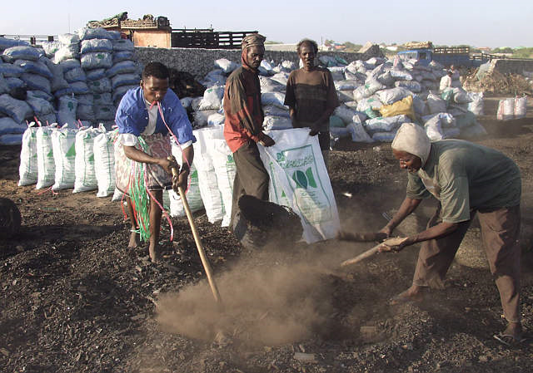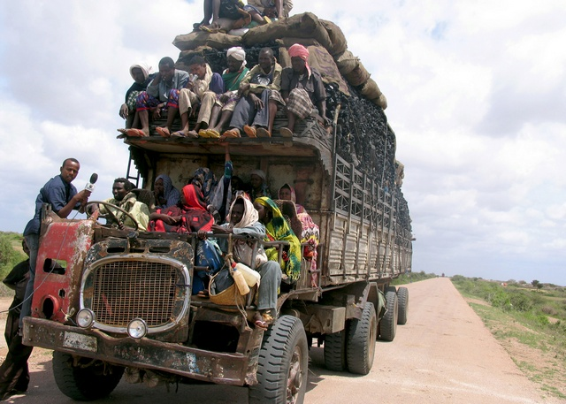
The Somali charcoal trade is evidence of Charcoal from Acacia trees destined for export
the lack of rule of law.

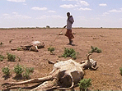
The effect of drought on livestock in Somalia

World G18 Somalia recommendations for action

*Environmental protection and agro-ecology
*Sustainable agricultural and food production through boosting crops
*More boreholes and wells to implement modern water harvesting projects
*Provision of sufficient sustainable water for both livestock and Irrigation
*Education and awareness training to accommodate climate change
*Soil and water conservation to avoid land degradation and soil loss through erosion
*Reduction in deforestation, charcoal burning and tree felling to improve the environment
*Renewable energy and biodiversity projects to minimize wood/charcoal use for cooking
*Establishing a unified campaign to protect ecology and wildlife
*Provision of good quality seeds for local farmers to enhance food production
*Facilitate and create platforms to enhance export marketing programmes
*Creation of sustainable employment in rural agricultural communities
*Provision of sustainable, well managed livestock and credible quarantine regime to
guarantee markets for meat exports
*Develop coastal fishery projects and associated work for coastal villagers
*Improve international marketing for Somalia’s fish and marine resources
*Initiate a sustainable drought prevention and recovery plan to benefit both animal and
human beings
*Improve soil fertility through ‘landscape rehydration’ methods
*Provide landscape management techniques, making more productive use of vegetation
*Improve rural area policies/ procedures of agricultural and environmental management
*Raise Somalia from its current extreme ‘food deficit’ status through improvements in
farming practices.

Prepared by Mahdi Aadam (Hon Secretary of World G18 Somalia)

